A

Summer Internship Project Report on

SMART GAMLA

Submitted to



## BIT AICTE IDEA LAB

**BHILAI INSTITUTE OF TECHNOLOGY, DURG**

An Autonomous Institute Affiliated to

### Chhattisgarh Swami Vivekanand Technical University, Bhilai (C.G.) By

Ayush Kumar Gupta Enrollment No. : BH3269, Computer Science and Engineering Piyush Kumar Enrollment No. : BK3705, Electrical Engineering

Divya Singh Enrollment No. : BK0689, Information Technology

Vishwas Verma Enrollment No. : BH2971, Electronics and Telecommunication Monika Sharma Enrollment No. : CB3139, Master of Computer Application Jyant Kumar Enrollment No. : BH2424, Mechanical Engineering

Ojaswi Sahu Enrollment No. : BH2918, Electronics and Telecommunication

### Under the Guidance of

Mr.Anupam Agrawal Assistant Professor

Electrical and Electronics Engineering

### Session: 2021 – 2022

We, the undersigned solemnly declare that the report of the project work entitled “Smart Pot”, is based on our own work carried out during the Summer Internship Programme at BIT AICTE IDEA LAB under the guidance of Mr.ANUPAM AGARWAL. We assert that the statements made and conclusions drawn are an outcome of the project work. We further declare that to the best of our knowledge and belief that the report does not contain any part of any work which has been submitted for the award of any other certificate in this University of India . All help received and citations used for the preparation of the report have been duly acknowledged.

Ayush Kumar Gupta University Roll No.:300102219024

Enrollment No.:BH3269 Sem:6

Branch:C.S.E

Piyush Kumar University Roll No.:300102420047

Enrollment No.:BK3705 Sem:4

Branch:E.E

Divya Singh University Roll No.:300103320013

Enrollment No.:BK0689 Sem:4

Branch:I.T

Vishwas Verma University Roll No.:300102819123

Enrollment No.:BH2971 Sem:6

Branch:E.T.C

Jayant Kumar University Roll No.:300103719054

Enrollment No.:BH2424 Sem:6

Branch:MECH

Monika Sharma University Roll No.:500102121057

Enrollment No.:CB3139 Sem:2

Branch:M.C.A

Ojaswi Sahu University Roll No.:300102819070

Enrollment No.:BH2918 Sem:6

Branch:E.T.C



(Signature of the faculty incharge) Anupam Agrawal

Assistant Professor

Electrical and Electronics Engineering

This is to certify that the report of the Project submitted is an outcome of the project work entitled “Smart pot”, carried out by

Ayush Kumar Gupta bearing Univ. Roll No:300102219024 & Enrollment No. : BH3269 Piyush Kumar bearing Univ. Roll No: 300102420047 & Enrollment No. : BK3705 Divya Singh bearing Univ. Roll No: 300103320013 & Enrollment No. : BK0689 Vishwas Verma bearing Univ. Roll No: 300102819123 & Enrollment No. : BH2971 Monika Sharma bearing Univ. Roll No: 500102121057 & Enrollment No. : CB3139 Jyant Kumar bearing Univ. Roll No: 300103719054 & Enrollment No. : BH2424 Ojaswi Sahu bearing Univ. Roll No: 300102819070 & Enrollment No. : BH2918

Carried out under my guidance and supervision for certification of the Summer Internship Programme at BIT AICTE IDEA LAB of Bhilai Institute of Technology, Durg.

To the best of my knowledge and the Report

1. Embodies the work of the candidate him/herself,
2. Has duly been completed and
3. Is up to the desired standard for the purpose of which is submitted.



Signature of the faculty incharge Mr. Anupam Agrawal

Electrical and Electronics Engineering

Signature of the Co - Coordinator Dr. Pawan Kumar Patnaik BIT AICTE IDEA LAB

BIT, Durg

Signature of the Coordinator Dr. Mohan Kumar Gupta BIT AICTE IDEA LAB

BIT, Durg

The project work as mentioned above is hereby being recommended and forwarded for evaluation.

Signature of the Chief Mentor Dr. Arun Arora

BIT AICTE IDEA LAB

BIT, Durg

With deep regards and profound respect, We avail this opportunity to express our deep sense of gratitude and indebtedness to Mr. Anupam Agrawal faculty in charge, Department of Electrical and Electronics, BIT Durg for his valuable guidance and support. We are deeply indebted for the valuable discussions at each phase of the project. We consider it our good fortune to have got an opportunity to work with such a wonderful person.

We express our sincere gratitude to Dr. Arun Arora, Chief Mentor, Dr. Mohan Kumar Gupta, Coordinator and Dr. Pawan Kumar Patnaik, Co-coordinator, BIT AICTE IDEA LAB Bhilai Institute of Technology, Durg for providing adequate infrastructure to carry out present investigations and also motivating for project work, which has been a constant source of inspiration in completing this work. We take immense pleasure to thank all the BIT AICTE IDEA LAB GURUs Dr. Anil Kumar, Dr. Santosh Mishra, Prof. Suchitra Pandey, Prof. Kauleshwar Prasad, Bhilai Institute of Technology, Durg, for motivating to work on Project and providing opportunities to connect with global research.

We wholeheartedly extend our gratitude to Mr. Anupam Agrawal, Department of Electrical and Electronics, BIT Durg for constant feedback and encouragement and endless support and help throughout this project work.



Ayush Kumar Gupta Piyush kumar Divya Singh Jayant Sahu



Monika Sharma Vishwas Verma Ojaswi Sahu

Air pollution and global warming are problems that have happened in India since the past to nowadays. People are becoming more interested in planting trees. But most people have an obligation to do things, such as going out for business trips that take a long time, so this problem makes people not have time to look after their plants/trees to the full capacity and the tree might die faster than normal. So, we decided to produce a small tree smart pot that can convenience users and prove their problem. It consists of Arduino UNO, soil moisture sensor, temperature sensor and small water pump. It can measure and show soil moisture value and temperature and display it in the i2c lcd screen engraved in the smart pot itself. Users can check whether soil moisture is high or low , pump status,temperature and humidity on the LCD screen. If soil moisture value is lower than standard the arduino will send a signal to the pump to work accordingly.

Keywords: planting, soil moisture, temperature, IoTs

|  |  |  |
| --- | --- | --- |
| **Figure No** | **Title of the Figure** | **Page**  **No** |

|  |  |  |
| --- | --- | --- |
| Figure 1 | Soil moisture sensor | 10 |
| Figure 2 | Temperature sensor | 11 |
| Figure 3 | Water sensor | 11 |
| Figure 4 | Mini pump | 12 |
| Figure 5 | L298 | 13 |
| Figure 6 | Arduino UNO | 14 |
| Figure 7 | LEDs | 14 |
| Figure 8 | Jump wires | 15 |
| Figure 9 | Pratham 1.0 | 16 |
| Figure 10 | Snapmaker | 16 |
| Figure 11 | Circuit Diagram | 18 |
| Figure 12 | 3D Model | 19 |
| Figure 13 | Assembled 3D Model | 19 |
| Figure 14 | Smart Gamla | 21 |

|  |  |  |
| --- | --- | --- |
| **Chapter** | **Title** | **Page No.** |
| **I** | **Introduction** | 7 |
| **II** | **Problem Identification and Motivation** | 8 |
| **III** | **Methodology** | 9 |
|  | 3.1 Objectives | 9 |
|  | 3.2 Hardware& Software Required | 10 |
|  | * + 1. Hardware Required     2. Software Required   3.2 Simulation model of System | 17  18 |
| **IV** | **Results and Discussion** | 20 |
|  | 4.1 Images of Completed Project | 21 |
| **V** | **Conclusion and Future Scope** | 22 |

#### References

**Appendix (Source Code)**

## INTRODUCTION

Sometimes when we go away from home for a few days or are really busy the house plants (unfairly) suffer because they are not watered when they need it. This is my solution.

It's a Smart Plant Pot which includes:

* 1. Inbuilt water reservoir.
  2. A sensor to monitor the moisture level of the soil.
  3. A pump to pump water to the plant when required.
  4. A water level monitor in the water reservoir.
  5. A LED to let you know when everything is OK, or if the water reservoir is nearing empty.

All the electronics, pumps and water reservoir are contained inside the pot to keep it looking smart. Each pot (if you make more than one) can also be set to the needs of different types of plants. It has an Arduino Nano controlling everything and the cost of the components has been kept as low as possible.

## PROBLEM IDENTIFICATION AND MOTIVATION

With the increase in population, civilization is developing at an understandable rate, due to which the land area for plantation is declining at a high speed. So, by making use of pots, this issue is being handled. A smart pot helps individuals to be independent and stress free for taking care of their plants, while one needs to fill the container (water) from time to time when needed. A smart watering system that automatically waters a plant.

## METHODOLOGY

### OBJECTIVE

The Project has 2 parts: software and hardware. As part of the software, the application was designed to work by itself once installed. Arduino UNO will check data of soil moisture, if soil moisture is low then the display will show it and the motor will pump water to the soil and hence the smart pot will water the plants by itself. We also have a storage tank to store water ,when the water level in the tank become low the red light will blink 3 times in a row and will blink continuously for about 3 seconds else it will be green forever .In part of hardware, we have used an Arduino UNO to connect soil moisture sensor, temperature sensor together along with water sensor ,a motor and two LEDs(Red and Green). We write down commands on Arduino UNO to make sensors work. The function of the pot in this project is to check the value of moisture in soil and temperature in the air to show the value in the application. When soil moisture is low, the pump will be on automatically until the soil moisture becomes optimum for the plant.

#### Functionalities:

* In part of model, the pot has a mini water pump to pump the water into soil in the pot.
* Soil moisture sensor and temperature sensor used to detect moisture in soil and take the temperature in the air and show value in the application.

## HARDWARE REQUIRED

#### Soil moisture sensor

The Soil Moisture Sensor uses capacitance to measure the water content of soil (by measuring the dielectric permittivity of the soil, which is a function of the water content). Simply insert this rugged sensor into the soil to be tested, and the volumetric water content of the soil is reported in percent.

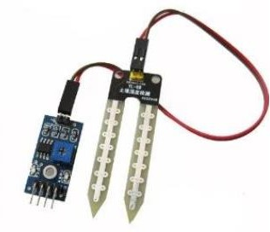

#### Figure 1 Soil moisture sensor

1. **Temperature sensor**

A temperature sensor detects the temperature of an object or of its environment and converts the reading into an electrical signal. Common types of temperature sensors include thermocouples, resistance temperature detectors (RTDs), thermistors, local temp sensor ICs, and remote thermal diode temperature sensor ICs. Thermocouples, RTDs, and thermistors are sensing elements with electrical properties that vary predictably with temperature. Local temperature sensor ICs utilize the physical properties of transistors on the die as the sensing element. Clinical grade temp sensors meet the clinical thermometry specification of the ASTM E1112 for accuracy. Remote thermal diode temperature sensors employ an external bipolar transistor as the sensing element and include all the signal conditioning circuitry necessary to measure temperature using one or more external transistors.

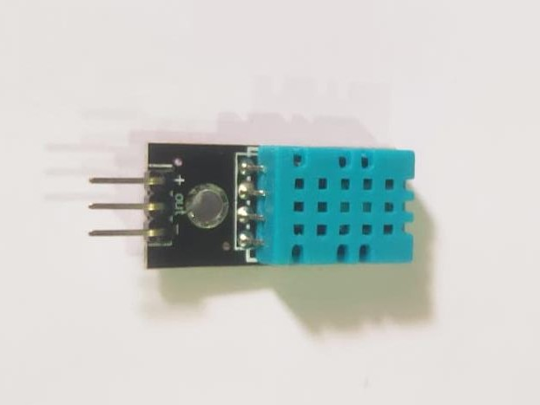

#### Figure 2 Temperature sensor

1. **Water sensor**

Connecting a water sensor to an Arduino is a great way to detect a leak, spill, flood, rain, etc. It can be used to detect the presence, the level, the volume and/or the absence of water. While this could be used to remind you to water your plants, there is a better Grove sensor for that. The sensor has an array of exposed traces, which read LOW when water is detected.

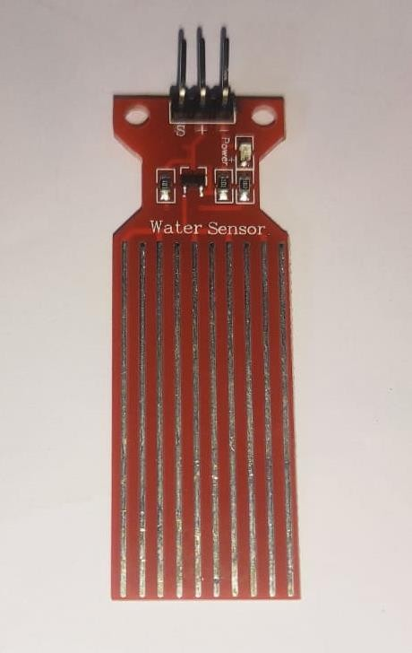

#### Figure 3 Water sensor

1. **Mini pump**

Mini pump is a low cost mini submersible type water pump that works on 3-6V DC. It is extremely simple and easy to use. Just immerse the pump in water, connect a suitable pipe to the outlet and power the motor with 3-6V to start pumping water. Great for building science projects, fire-extinguishers, firefighting robots, fountains, waterfalls, plant watering systems etc. This motor is small, compact and light. It can be controlled from a microcontroller/Arduino using our DC Motor Drivers or one of our Relay Boards. You may use our 5V SMPS Power Supply Adapter to run this pump. You may also use our 6V Solar Panel to run the pump with appropriate a 6V voltage regulator.

Note: Do not run the pump dry (without putting it in water) and do not use it to pump flammable liquids.

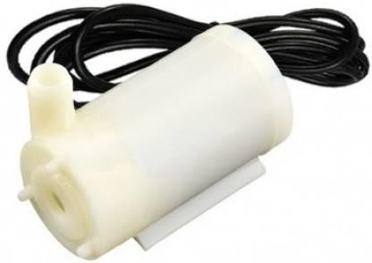

#### Figure 4 Mini pump

**5.L298**

The L298 is an integrated monolithic circuit in a 15-lead Multiwatt and PowerSO20 packages. It is a high voltage, high current dual full-bridge driver designed to accept standard TTL logic levels and drive inductive loads such as relays, solenoids, DC and stepping motors. Two enable inputs are provided to enable or disable the device independently of the input signals. The emitters of the lower transistors of each bridge are connected together and the corresponding external terminal can be used for the connection of an external sensing resistor. An additional supply input is provided so that the logic works at a lower voltage.

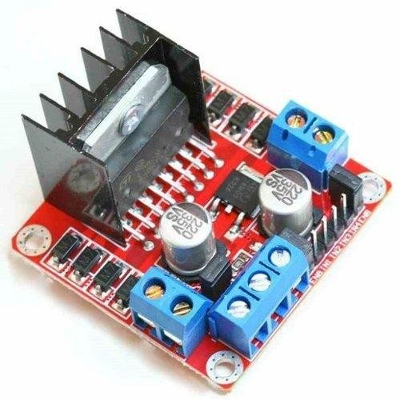

#### Figure 5 L298

1. **Arduino UNO**

The Arduino UNO is a standard board of Arduino. Here UNO means 'one' in Italian. It was named as UNO to label the first release of Arduino Software. It was also the first USB board released by Arduino. It is considered as the powerful board used in various projects. Arduino.cc developed the Arduino UNO board.

Arduino UNO is based on an ATmega328P microcontoller. It is easy to use compared to other boards, such as the Arduino Mega board, etc. The board consists of digital and analog Input/Output pins (I/O), shields, and other circuits.

The Arduino UNO includes 6 analog pin inputs, 14 digital pins, a USB connector, a power jack, and an ICSP (In-Circuit Serial Programming) header. It is programmed based on IDE, which stands for Integrated Development Environment. It can run on both online and offline platforms.

The IDE is common to all available boards of Arduino.

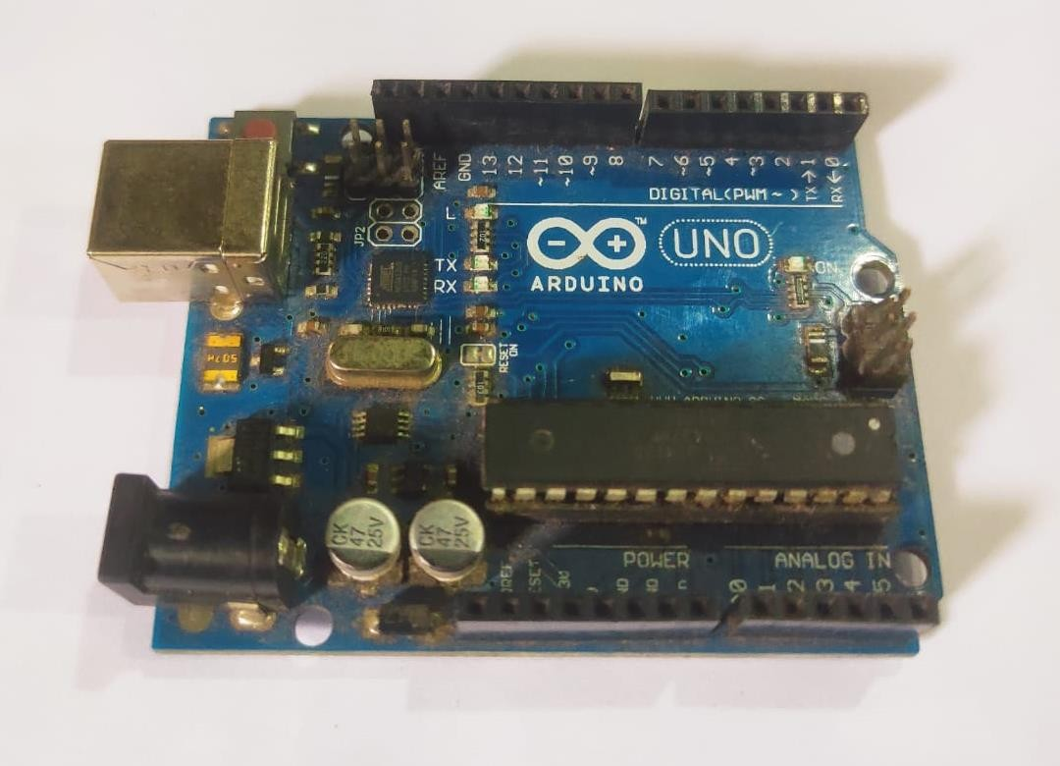

#### Figure 6 Arduino UNO

1. **LEDs**

A light-emitting diode (LED) is a semiconductor light source that emits light when current flows through it. Electrons in the semiconductor recombine with electron holes, releasing energy in the form of photons. The color of the light (corresponding to the energy of the photons) is determined by the energy required for electrons to cross the band gap of the semiconductor. White light is obtained by using multiple semiconductors or a layer of light-emitting phosphor on the semiconductor device.

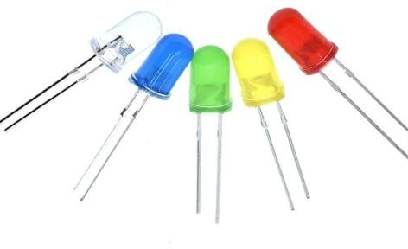

#### Figure 7 LEDs

1. **Jump wires**

Also known as jumper, jumper wire, DuPont wire is an electrical wire, or group of them in a cable, with a connector or pin at each end (or sometimes without them – simply "tinned"), which is normally used to interconnect the components of a breadboard or other prototype or test circuit, internally or with other equipment or components, without soldering.

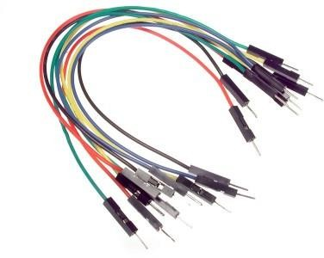Individual jump wires are fitted by inserting their "end connectors" into the slots provided in a breadboard, the header connector of a circuit board, or a piece of test equipment.

#### Figure 8 Jump wires

**9.3D printing**

It is the construction of a three-dimensional object from a CAD model or a digital 3D model.The term "3D printing" can refer to a variety of processes in which material is deposited, joined or solidified under computer control to create a three dimensional object,with material being added together (such as plastics, liquids or powder grains being fused together), typically layer by layer.

3D printers used in our project are: 1.Pratham 1.0

2.Flash forge 3.Snapmaker

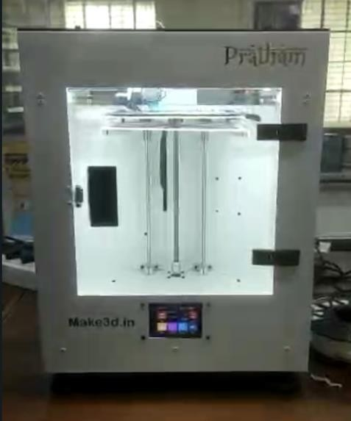

#### Figure 9 Pratham 1.0

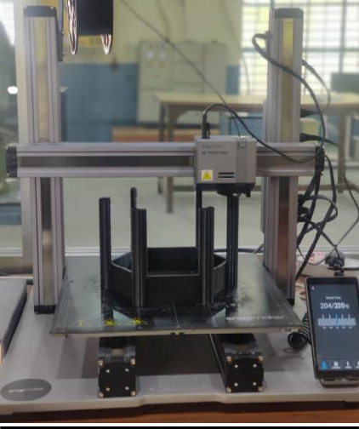

**Figure 10 Snapmaker**

#### Arduino IDE v1.8.19

The open-source Arduino Software (IDE) makes it easy to write code and upload it to the board. This software can be used with any Arduino board.

#### SketchUp

It is a suite of subscription products that include SketchUp Pro Desktop, a [3D modeling](https://en.wikipedia.org/wiki/3D_modeling) [computer](https://en.wikipedia.org/wiki/Computer_program) [program](https://en.wikipedia.org/wiki/Computer_program) for a broad range of drawing and design applications — including [architectural,](https://en.wikipedia.org/wiki/Architecture) interior design, industrial and product design, landscape architecture, [civil](https://en.wikipedia.org/wiki/Civil_engineer) and [mechanical engineering](https://en.wikipedia.org/wiki/Mechanical_engineering), theater, film and [video game](https://en.wikipedia.org/wiki/Video_game_developer) development.

#### Fusion 360

It is a cloud-based 3D modeling, CAD, CAM, CAE, and PCB software platform for product design and manufacturing. Design and engineer products to ensure aesthetics, form, fit, and function.

#### FlashPrint

It provides a simple and easy to use user interface for preparing your 3D designs for printing on the Flashforge 3D printers.

#### Snapmaker Luban

It is a free tool that will help you generate G-code for your 3D printing or laser cutting projects.

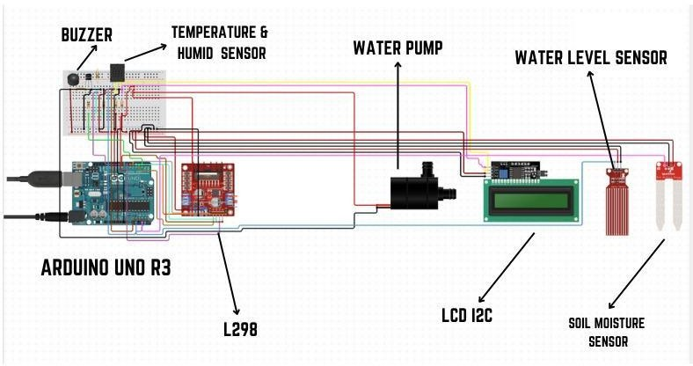

#### Figure 11 Circuit Diagram

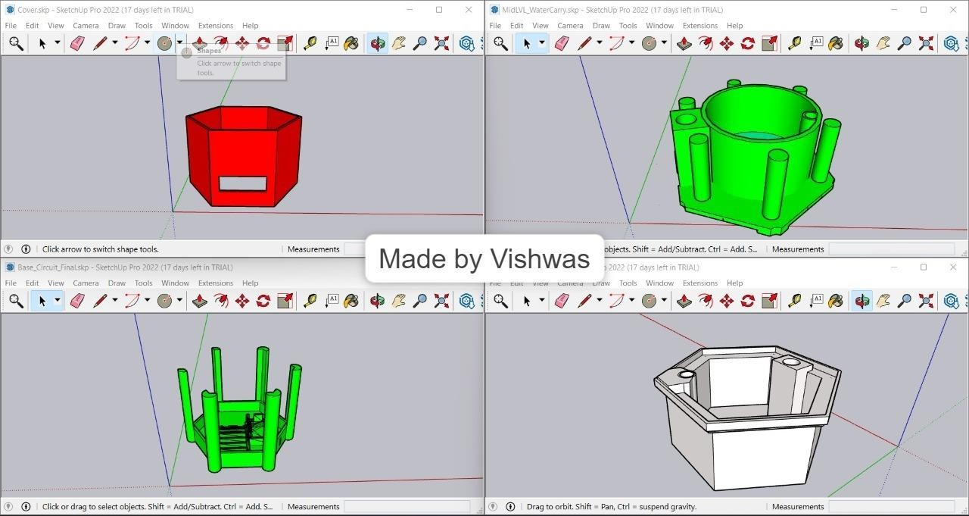

**Figure 12 3D Model**

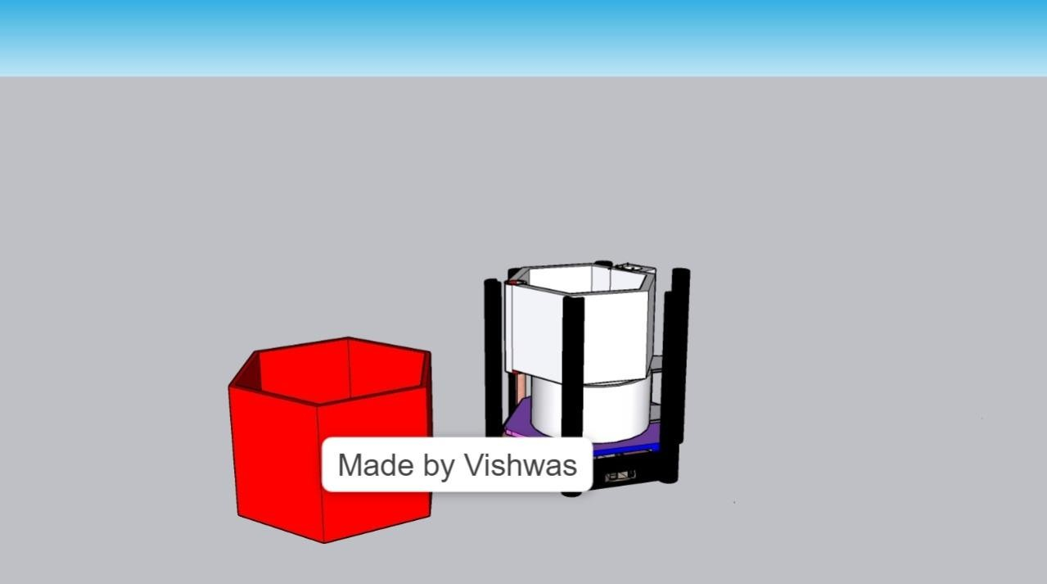

**Figure 13 Assembled 3D Model**

# CHAPTER IV

## RESULT AND DISCUSSION

In particular, the IoT technology is applied to plant pots which are used at home for various purposes, so that IoT based plant pots sell in the market. However, most of the smart pots fail to take into account species of plants and are recommended to be used for particular plants only. With the change and development of overall social environments like industrial advancement, the number of one-person households is on the constant increase. For various reasons, such as fatigue in busy urban life, environmental issues like fine dust, and a changing lifestyle, people try to find diverse ways to recover their psychological stability. In particular, more people grow plants to regain their mental stability in the way of looking at flowers and fruits of their plants. In the US, even young people are more interested in growing plants since their satisfaction is high in terms of cost. According to the report of New York Times, a great deal of people who newly enter the plant growth market was millennium generation [3]. In this aspect, it is necessary to research the system platform that can expand or reduce to a customized system by meeting different user needs in any circumstances. It is designed with

* ➢Arduino UNO R3
* ➢Buzzer
* ➢L298
* ➢LCD I2C
* ➢Water pump
* ➢Water level sensor
* ➢Soil moisture sensor
* ➢Temperature & Humidity sensor

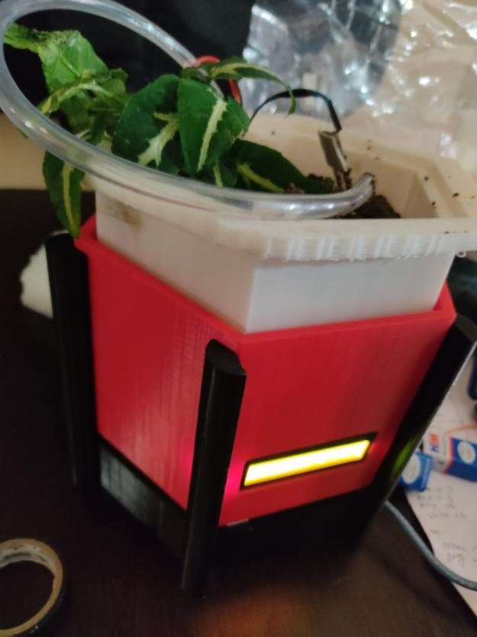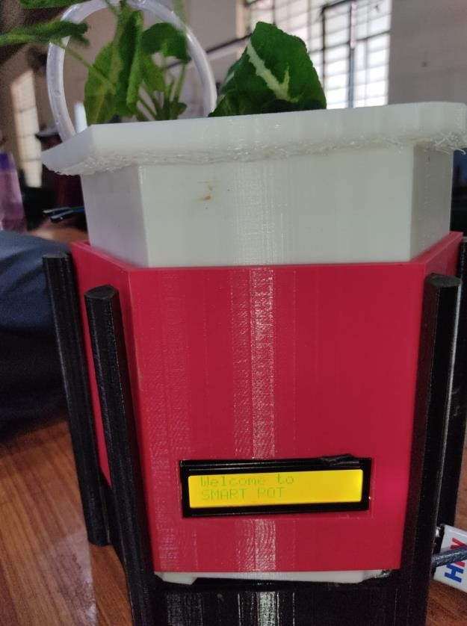

#### Figure 14 Smart Gamla

From the experimental results, we concluded that ‘Mini Pot’ can be used with small trees that plant in offices. Soil moisture and temperature sensors can work well with mobile applications. Users can leave the pot as it is and the water pump will automatically water the plant. The display can show temperature, soil moisture, humidity value data in real-time. We have drilled a little hole in the bottom of soil container in order to drain the water too, because if not draining the water out it may cause the roots of the tree to rot.However, the researchers recommend using ‘Smart Pot’ on small trees for accuracy of sensors that will show data accurate.

Future scope:

We can update or modified our gamla by making an app from:

[https://community.appinventor.mit.edu/t/bluetooth-hc-06-arduino-send-receive-send-text-file-](https://community.appinventor.mit.edu/t/bluetooth-hc-06-arduino-send-receive-send-text-file-multitouch-image/9518) [multitouch-image/9518](https://community.appinventor.mit.edu/t/bluetooth-hc-06-arduino-send-receive-send-text-file-multitouch-image/9518)

How will it work?

For this we will have to use the Bluetooth module(HC-06) . We can connect it with our Arduino or esp32. So that it act as interfacing between our mobile phone and gamla.we can get all the details of our gamla from our smartphones like temperature, humidity, moisturization, whether pump is on or off, the water tank of our gamla is filled with water or not.

# REFERENCES

1. [https://www.circuito.io/app?components=512,11021](https://www.circuito.io/app?components=512%2C11021)
2. [https://www.wikipedia.org](https://www.wikipedia.org/)
3. <https://youtu.be/w5bRUKZnd1k>
4. <https://youtu.be/GNNzLwCidCE>

# APPENDIX(SOURCE CODE)

1. <https://github.com/Piyushk01/piyush-kumar>
2. <https://github.com/Piyushk01/piyush-kumar/find/main>